**Synthesis of a controller for reactive applications**

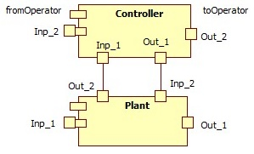

**The synthesis problem**

The specifications are based on the OETPNP model of the plant, term used here as a generic name. The *plant* can be: a vehicle, a tool, a device, or even another software application. The OETPNP model describes the Plant's behavior in a specified initial state and interactions with the outside of the plant.

It is specified for the Plant:

* Inp_1 input channels that create uncontrolled and unknown events or data streams (by the Controller) in general; the types of this information must be compatible with the places of the plant; sometimes human operators can interact with the installation through some of the input channels in the Inp_1 set;
* Out_1 output channels that generate events and data streams outside the plant, but which are not (generally) measured directly (or at least not all) by the Controller; sometimes human operators can receive information about the plant through channels in the Out_1 set;
* Out_2 output channels provide events and data streams that can be retrieved by the Controller; their types must be compatible with the corresponding types of the places in the Controller;
* Inp_2 input channels provide (controllable) information to the plant; they must be specified if they are events or data streams and their types are specified;

The *controller* here means a program that interacts with the Plant and determines the latter to have an evolution required by the specification requirements.

*Specification requirements* describe how the Plant should behave. It is possible for a human operator to interact with the Controller or even the Plant during evolution.

From the specification requirements, the OETPNR model (or a set of models) is constructed, which formally describes the required behavior of Plant.

Examples of requirements are:

* If the Plant is in a specified state and if the inputs receive specified information (events or data streams), then the Plant must evolve on a certain trajectory required by the states, or avoid a state, possibly a sequence of states;
* If the Plant is in a certain state and a given event occurs, the Plant must act according to certain requirements, such as producing an event or sequence of events;

*Controller specifications include*:

* Inp_1 input channels through which information can be received from the Plant; they must be compatible with the output channels of the Plant; they can be of event type or data streams;
* Out_1 output channels through which the Controller can influence the behavior of Plant; they provide event type information or data streams; they must be compatible with the Inp_2 channels in the Plant;
* Inp_2 channels are used for taking orders from the operator in the form of events or data streams;
* Out_2 channels provide information to the operator in the form of events or data streams; capable devices are required to retrieve or display the type of the information provided.

The formal problem of the synthesis of the controller is to determine the model of the OETPNC controller and its initial state for the case where OETPNP is in the MP0state, and Plant's behavior corresponds to the OETPNR requirements with MR0.

For some problems, the external inputs for the Plant and the Controller are specified. The former are sometimes referred to as disturbances, and the latter often express the operator's instructions or commands.

**Example: Synthesis of vehicle traffic control through an intersection**



The infrastructure consists of 4 input lanes (ILi; i=1,2,3,4), 4 output lanes (OLi; i=1,2,3,4), 4 traffic lights (TLi, i=1,2,3,4) and 4 pairs of sensors αi, βi that can measure the inputs and outputs of the corresponding input lanes respectively. Sensors γi (i=1,2,3,4) can measure the inputs to the output lanes.

TLi has 3 states: red (r), yellow (y) and green (g). Cars can only pass when the traffic light indicates the color g. The color duration y is 5 seconds (sec.). The rule of intersection is 'only forward or right'.

**Event-based Plant model**

*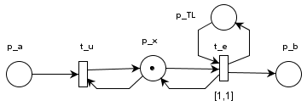The model of a lane* is: xc = xa + u – e

Where xc and xa represents the number of cars on the current and previous lane respectively, and u and e are the events when the entry / exit of a car is signaled. u and e have the value one, only when the respective sensor signals the passage of the machine, and the rest have zero value. The event model of the lane is represented in the attached figure.

Notations:

* p_a the input channel from the input sensor αi,
* p_b the output channel from the output sensor βi,
* t_u the transition that takes over the input event and add car objects to the array list in p_x
* p_TL the input channel through which TL commands are received (red, yellow, green)
* t_e the transition that models (and determines) the output of a car from the lane

The Place types are:

* type(p_a) = car object containing list of string to represent target transitions for the car route
* type(p_x) = arraylist of car with a dynamic size that is set by the user
* type(p_TL) = string = {red, yellow, green}
* type(p_b) = car object

The evolution rules associated with the transitions are:

* t_u: grd: (m(p_a) ≠ ϕ And m(p_x).CanAddCars)); map_u: list.add m(p_a);
* t_e: grd: (m(p_TL) = green And m(p_x).HaveCar()); map_e: m(p_b) = PopCar() (m(p_x));

where the method CanAddCars() checks if there is a available space in the arraylist, and the method HaveCar() pops a car form the arraylist to the desired place.

**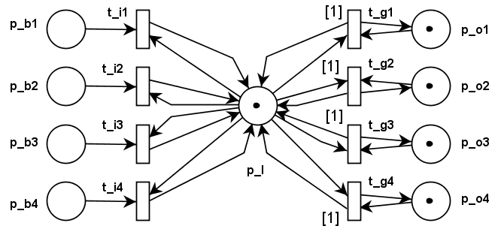***Intersection model:*

The paths of the open lanes in a phase cannot intersect. The system has two phases marked with: phase_1 (for IL_1 and IL_3) and phase_2 (for IL_2 and IL_4).

The attached model describes the behavior of the intersection.

The nodes meanings are:

* the exit places from the lanes at the intersection
* p_b1, p_b2, p_b3, p_b4
* the entrance transitions at the intersection t_i1, t_i2, t_i3, t_i4
* p_I models cars at the intersection at the current moment
* transitions t_g1, t_g2, t_g3, t_g4 delayed by 1 sec. Model the input events in the output lanes of the intersection
* the places p_o1, p_o2, p_o3, p_o4 model the cars leaving the exiting lanes

The place types are:

* type(p_b1) = type(p_b2) = type(p_b3)=type(p_b4)= car object;
* type(p_o1) = type(p_o2) = type(p_o3) = type(p_o4) = type(p_I) = array list of car with a dynamic size that is set by the user

The evolution rules associated with the transitions are:

* t_i1, ..., t_i4: (grd_b1: ((m(p_b1) ≠ ϕ) And (m(p_I).CanAddCars ())); map_i: list.add m(p_b));
* t_g1, ..., t_g4: (grd_g1: (( (m(p_I).HaveCarForMe())And (m(p_o).CanAddCars ())); map_o1: PopCar() (m(p_I), AddCar() (m(p_g1));

where the method HaveCarForMe() checks if the transition t_g1 is one of the target transitions in the car object.

**The plant model based on data streams**

Unlike the previous model that takes into account the events produced by cars, this model uses data streams. Input channels provide data streams.

In this case, the actual process of the car traffic system is regarded as vehicle flows that are modeled as data streams. In the actual process the vehicle flow is controlled, and in the model the data stream is controlled. The correspondence between the two types of flows is made by the input / output devices. There are sensors that can be read periodically or that can automatically provide vehicle flow parameters. These are generators of information for the controller who will calculate on their basis the commands that are transmitted to the traffic lights and thus control the vehicles flow.

Data streams has a frequency and a data type. Reading and writing in the stream is done with a specified period δ and there is a certain type (structure) of data (eg: real, integer) that are accepted.

The model of the previous lane can be transformed into a model based on flows. It is assumed that the sensor supplies with the period of 1 sec, the number of vehicles entered on the lane, and the sensor β on the one of the vehicles that came out in the same period of 1 sec. The palce p_x will store the number of vehicles on the lane at that time.

The mathematical model made is:

x(τ+1) = x(τ) + u(τ) – e(τ)

with τ noted as time.

There is the condition *max ≥ x(τ)*.

While u(τ) is an uncontrollable values, output e(τ) can be controlled by the value entered in the place p_TL. There is the real condition that the number of vehicles at a given time does not exceed the maximum number of vehicles that represents the lane capacity.

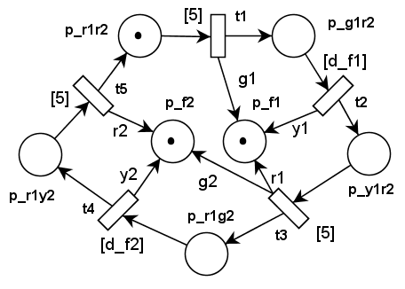**The model of the fixed phase controller of the phases**

For the controller synthesis it is required that the Plant allows the intersection periodically with the specified period divided between the two phases with the durations d_f1 and d_f2, for the change of phases the duration of the yellow color to be 5 sec. And the duration of red everywhere to be 5 sec.

The attached figure models the fixed-duration controller of the phases marked on the figure with d_f1 and d_f2.

The nodes meanings are:

* p_r1r2 is the place that expresses the red traffic lights everywhere (clearance red)
* p_g1r2 specifies the green color for phase 1 and red for phase 2
* p_y1r2 specifies the yellow color for phase 1 and red for phase 2
* p_r1g2 has a token when phase 1 is red and phase 2 is green
* p_r1y2 has a token if phase 1 is red and phase 2 is yellow
* Transitions t1, t2, ..., t5 marked on the colors the colors they impose on the two phases

Transitions t1, t3, t5 have delays of 5 sec each.

The place p_f1 and p_f2 are output channels that must be connected to traffic lights p_TL1, ..., p_TL4 at the intersection. Initially these channels are red, and the controller is in its original state p_r1r2.

Type(p_r1r2) = Type(p_g1r2) = Type(p_y1r2) = Type(p_r1g2) = Type(p_r1y2) = String;

Type (p_f2) = type (P_f2) = DataOverNetwork; that contains the token and a string for the IP address and an integer for the port number.

The guard for transition:

* t1: (grd_1: ((m(r1r2) ≠ ϕ); map_f1: SendOverNetwork(green); map_g1r2 = map_r1r2);
* t2: (grd_2: ((m(g1r2) ≠ ϕ); map_f1: SendOverNetwork(yellow); map_y1r2 = map_ g1r2);
* t3: (grd_3: ((m(y1r2) ≠ ϕ); map_f1: SendOverNetwork(red); map_f2: SendOverNetwork(green) ); map_r1g2 = map_ y1r2);
* t4: (grd_4: ((m(r1g2) ≠ ϕ); map_f2: SendOverNetwork(yellow) ); map_r1y2 = map_ r1g2);
* t5: (grd_1: ((m(r1y2) ≠ ϕ); map_f2: SendOverNetwork(red) ); map_r1y2 = map_ r1r2);

**Controller model with variable phase durations (closed-loop controller)**

The open-loop controller does not consider changing vehicles flows for which the phase durations were calculated.

The variable duration controller must adapt them according to the information received from the sensors (or detectors). Sensors can provide vehicles entry or exit events, vehicles entry and exit rates, so vehicle flows or can measure (estimate) the lengths of queues for waiting vehicles.